Assignment 1

1. Install Power BI Desktop and share the final screenshot of the report view page which appears when power desktop starts.

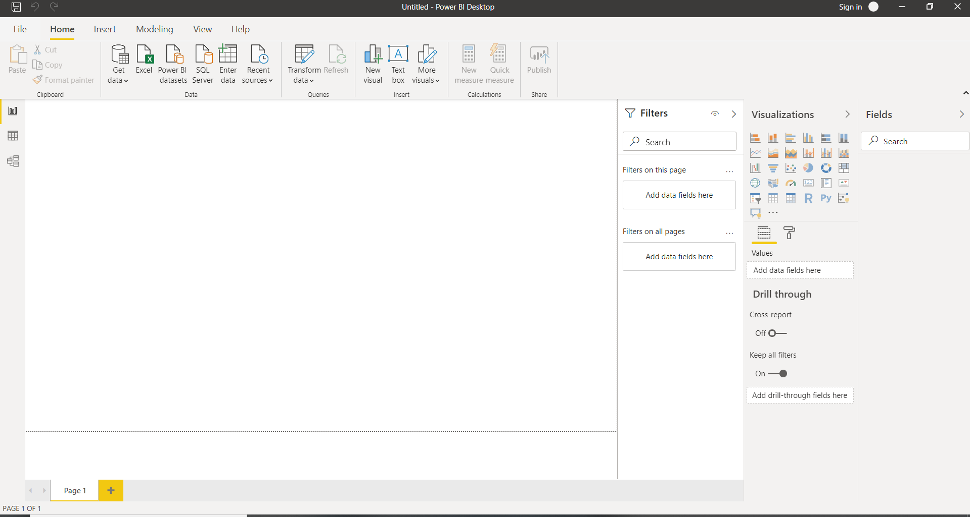

2 . Prepare a document and with the following screenshot

− Report View:

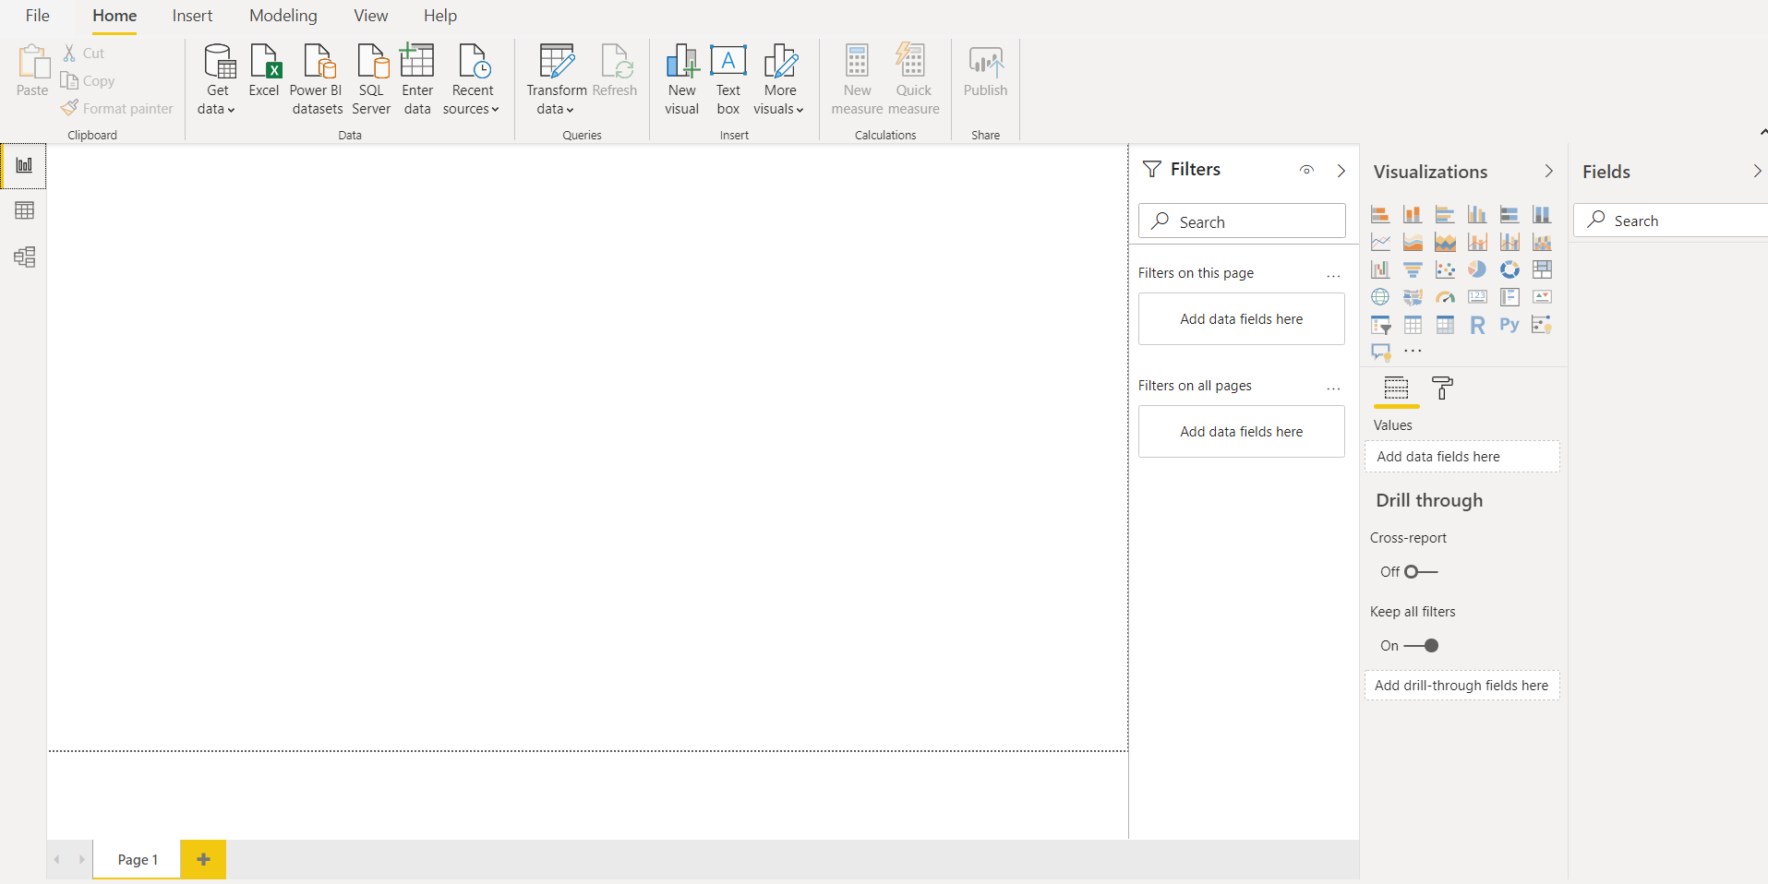

− Data View

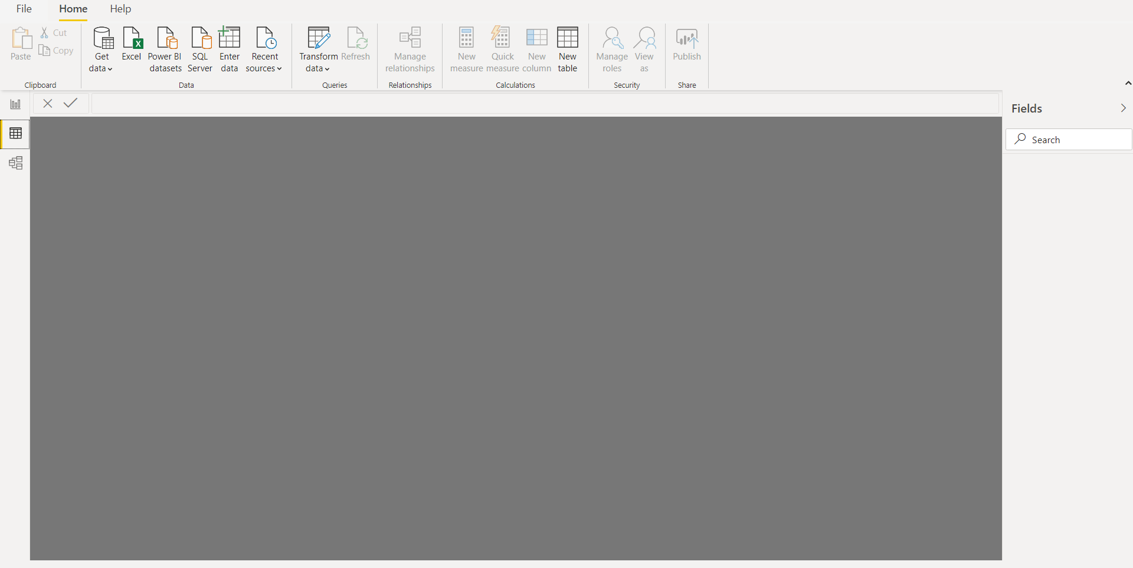

− Model View

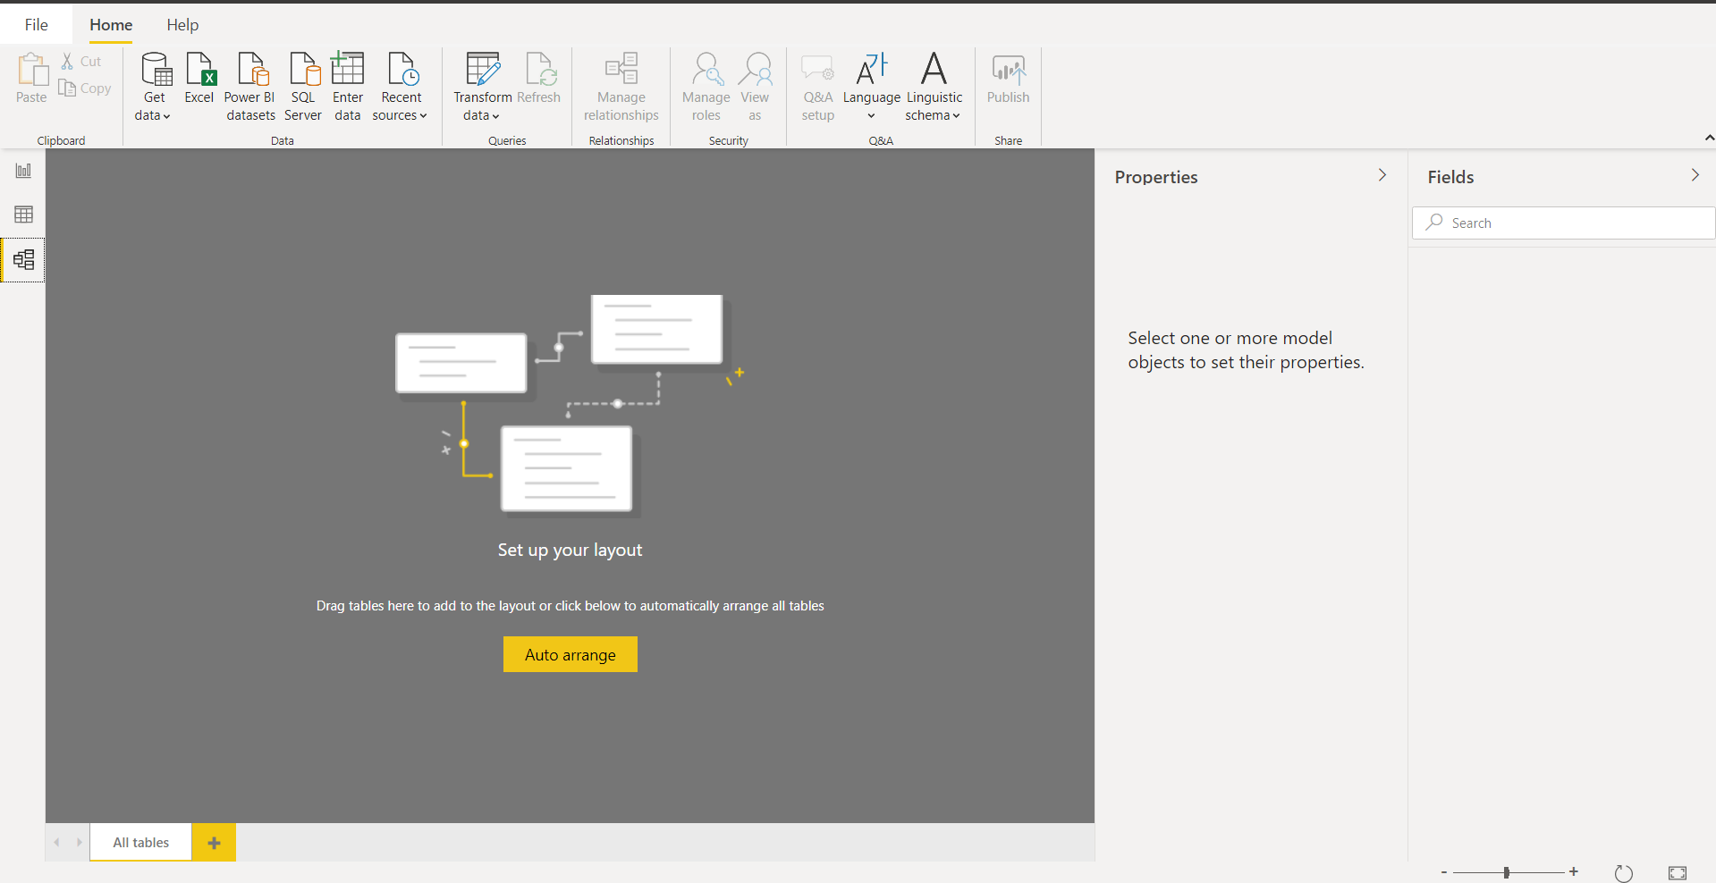

− Power Query Editor

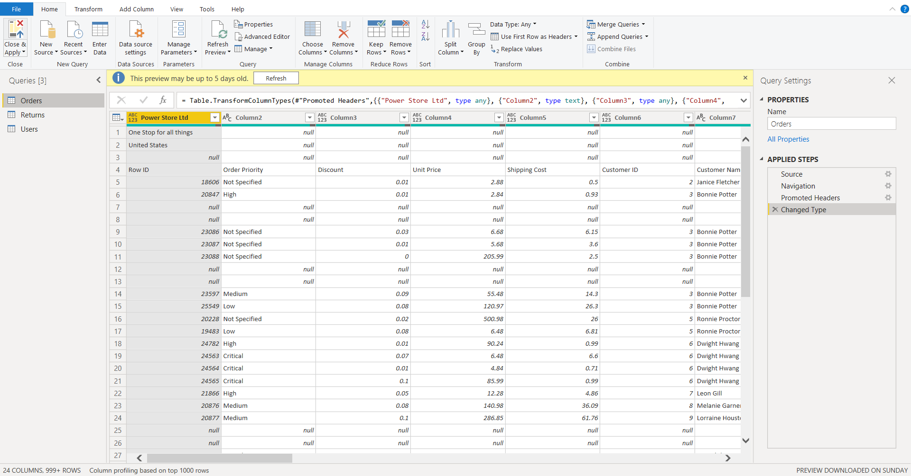

− Advance Editor

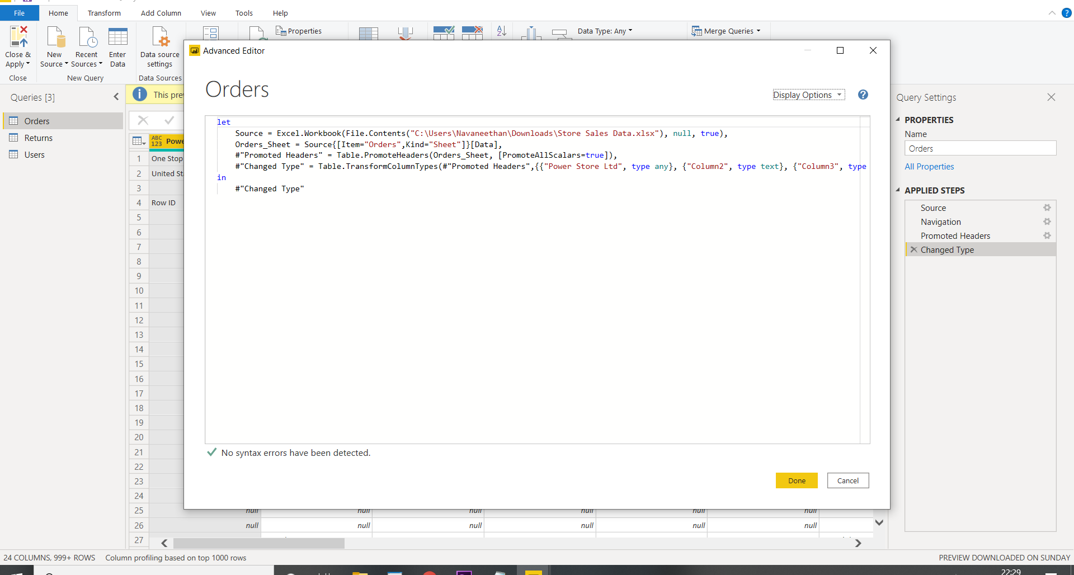

3. Prepare a document with details of the following along with their price

− Power BI Desktop:

free to any single user

− Power BI Pro

$9.99/user/month

− Power BI Premium

$4,995 a month